Analyzing the Power Consumption of Various states using Python

Our objective was to analyze the power consumed by various states in our country, and to be able to deduce where we can lower the power consumption or switch to renewable options.

We analyzed the power consumption for the year 2019-20, pre and during lockdown period, how various industries and residential areas consumed electricity. We generated the graph and Heatmaps for better data visualization.

From our observations of state-wise analysis, we were able to see that Maharashtra was the highest consumer while Sikkim was on the lower end of the spectrum. While region-wise Western and Southern states were the major consumers while North-eastern states were the minor consumers of electricity.

While comparing northern and southern regions, consumption of power for southern region was slightly higher, on the other hand for eastern and western region, eastern regions consumed less power.

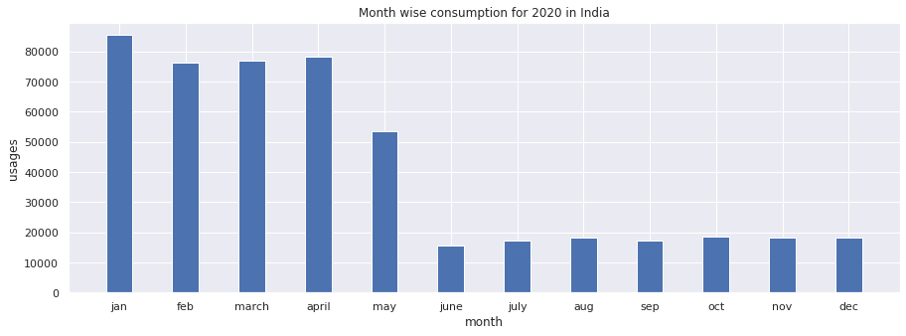

Overall Power consumption in India for 2019 have only slight variations, being almost same throughout. In 2020 January-March the consumption of power was at similar level, though after lock-down being imposed due COVID 19 (mid-March) saw drastic fall, with service industries, other major power consuming industries being on-hold, residential area was the key power consuming unit in the country.